SVTTA 15 TT SPEED FAMILY TROPHY

SUNDAY 25 SEPTEMBER 2022
8.00 AM START
COURSE – WM15/01

Headquarters: Cambusbarron Village Hall, Cambusbarron, Stirling FK7 9NU

PROMOTED BY: Scottish Veteran Time Trial Association
Under CTT
Rules and Regulations

Organiser: Mhairi Laffoley, 22 Frankfield Place, Dalgety Bay KY11 9LR
Tel: 01383 822349 or email: mhairilaffoley@gmail.com

Timekeepers – Start: Andy Williams Finish: Catriona Stirling Recorder: Sarah Williams

Event Headquarters Open from 7 AM

Race Program

Parking:

Parking is available on-street or at the small car park at the HQ.

Please note: Parking will not be allowed in the adjacent Bowling Club Car Park or in the housing estate behind the hall nor will there be parking at the event start or finish.

Start:

The start is on the A811 approximately ½ mile to the East of the Kersebonny Road end, Cambusbarron. It is approx. 1 ½ miles from the event HQ.

The start is accessed from Cambusbarron village by turning right from the HQ entrance, proceeding into the village, turning right down Mill Brae after about a quarter of a mile and left onto Mill Road, which leads to Kersebonny Road. Turn right at the end of the Kersebonny Road (please take extra care as you will be turning over the course/traffic and riders will already be underway) and head East towards Stirling Castle. Cross the motorway flyover and the start is approx. 320 m west of Clay Toll Roundabout.
Please DO NOT warm up on the course but note that you will need to cross through the finish line to make your way to the start. If you are on the way to your start DO NOT adopt a racing position as you go through the finish area to avoid confusion for the timekeeper and take care not to interfere with those racing.

Map of route from HQ to the A811
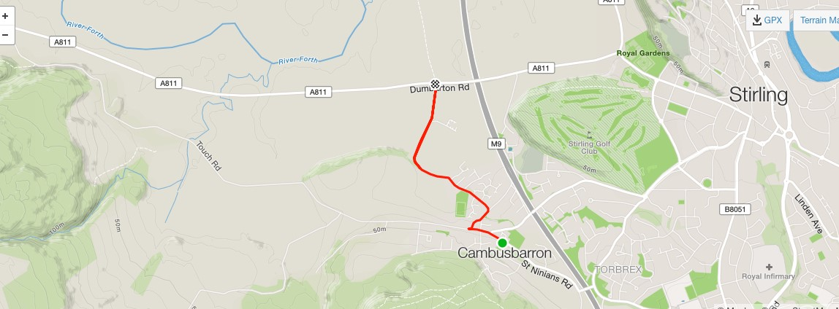
The course:

The course is an out and back along the A811. From the start it heads west to turn at the Kippen roundabout. There will be Marshals at this point. They are not allowed to stop traffic so riders must adhere to highway code when negotiating the roundabout. Retrace along the A811 crossing over the motorway flyover and finish at the entrance to Falleninch Farm. On your return to the HQ please be considerate whilst riding on A811 back to Kersebonny Road as there will be other riders who have just started their race.

Other Important Information:

- Please make sure that you give yourself enough time to get to the start line. There is a small layby opposite the start but remember that the timekeeper needs to park there. The road at the start can be busy so please take care whilst waiting to start.

- Riders MUST have both a working front and rear light fitted to their bike.
NO lights NO start.
- Riders should NOT stop at the finish area and should continue to HQ where they need to SIGN OUT. If you DO NOT sign out, you will be recorded as a DNF.
- Please DO NOT ride with your head down. There are often slow-moving tractors, etc on this course and as exit from some of the bends you may come across them so please remain vigilant.
- Refreshments and Prize Giving will take place back in the hall.

The organiser extends her thanks to all the volunteers helping today, as without their participation the race would not be able to go ahead.

